**TMAY - Tell Me About Yourself**

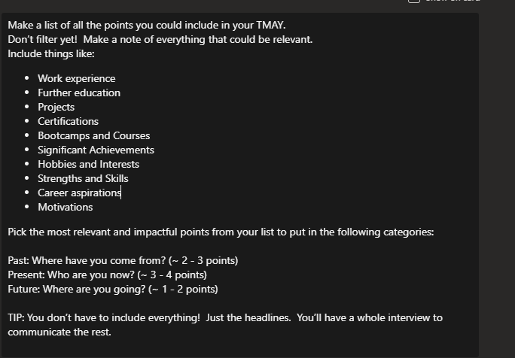

1. **Work Experience:** Data Consultant, Business Analyst, Intern Data Analyst, Intern Office Administrator, Pier Operative, Mathematics Tutor
2. **Further Education: A-Levels(A*,A,C)**
3. **Projects:** 
   1. At my previous job, the main coding language that was being used was SQL and so given that I had basic knowledge of python, I took the initiative of creating demo dashboards for the company I was working with, in which it would demonstrate to a potential client, the tools and services provided within the company.
   2. As part of an internal project, I’ve automated model processes, in which I’ve reduced the need of any manual interaction. The model already built in required me to ingest data on a daily basis, validate this data against previous day data and ensure the differences meet specific thresholds, then moving this to the live environment all was done manually. Creating stored procedures using SQL, I ensure to automate these processes and create error conditions if they do not match the criteria.
4. **Certifications:**
5. **Bootcamps & Courses:**
   1. Aiming to do the Microsoft Fabric Data Engineering
6. **Significant Achievements:** 
   1. First Class Honours in Mathematics with Statistics from King’s College London
   2. National Romanian Gold Medallist in Mid-Distance running from the age of 10- 14
7. **Hobbies and Interests**
8. Enjoy doing strength training and cardio workouts like swimming, running, hiit workouts
9. Watching action related films, listening to podcasts: Diary of a CEO, Jay Shetty, people’s experience
10. **Strengths & Skills:**
    1. Resilient
    2. Solid communications skills
    3. Analytical mindset
    4. SQL, Basic Python
    5. Data Manipulation using SQL,Python
    6. Data querying
11. **Career aspirations**
    1. Experienced data analyst
12. **Motivations**
    1. Bridge the gap between technical expertise and real-world business projects.

**Past: Where have you come from?** I am Madalina, I am originally from Romania and moved to the UK 11 years ago to pursue studies and a career. Studied mathematics with statistics and graduated with a first class honours from king’s college london. Shortly after I took the opportunity to work as a data consultant for a FTSE-100 company in which I maintained and developed activity based costing models using SQL,Python, Excel & Power BI. Also took initiative of automating model processses and created demo dashboards for the company to gather leads.

I was also a high performance mid distance runner back home, which built my discipline persona in the person I am today, actively looking to progress and being resilient in all the things that I do.

**Present: Who are you now?**

Now, I am looking to progress within the data field and bridge the gap between technical expertise and real-world business projects through the academy at Sparta. Where I see myself is becoming a strong data leader and be able to apply these skills confidently within any business sector.

High performance athlete-mid distance runner, evidence of a skill, always been driven

* Include team leader opportunities,
* Include Mapogos experience, how you have scaled up this SME
* Remove bridge the gap between technical expertise and real-world business
* What do you want
* Remove problem solving, drive unless evidence, provide evidence

Staying active whether that’s going to the gym, running/ swimming gives me the opportunity to self-discipline, stay productive and to sharpen my mind. Actively listening to podcasts to improve creative, and analytical skills, podcasts with Diary of a CEO, Jay Shetty..

**Future: Where are you going?**

To become a successful data engineer, and Become a good data leader, whether that’s senior consultant or data scientist and be able to apply these skills confidently within the business sector project manage within big data and create my own portfolio to apply to all sectors.

**Questions to consider:**

Tell me about yourself?

Why do you want to be a Data Engineer?

Why would you make a good Data Engineer?

* Really enjoy solving problems, in my spare time play chess, at sparta filled the gaps and learned to become a better consultant.
* Make unstructured, ugly data into a pretty insightful reports

What skills are most important for a Data Engineer?

* Give numbers meaning,

What are your weaknesses?

What is your biggest strength?

What are your career aspirations?

Where do you see yourself in 5/10 years?

What have you covered in your training so far?

Can you explain your latest project you have done at Sparta?

A sheet metal manufacturer wants to perform analysis and find potential trends on their data, how would you consult them?

-find out about company and manufacturer and business a whole, output, customers their shipping, competitors.

1. Crucial to know what are they hoping to achieve? (reduce waste, forecast demand??)

2. Explore what data they currently collect and asses (operations data/supply chain/sales data)

3. Identify key analytical angles (Cost &Waste analysis/customer & product profitability)

https://sqlfiddle.com/sql-server/online-compiler?id=075953b3-7ac2-4cf9-9b17-6d0b8209da89